MARKET DEEPING
Neighbourhood Policing Team

YOUR LOCAL TEAM
StamfordBourneAndDeeping@lincs.police.uk
 | 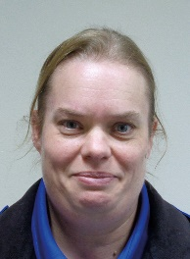
PC Claire Wilson | PCSO Rowena Everitt

FORTHCOMING ENGAGEMENTS
Mini Police Officers are close to completing their first year. All have shown professionalism & commitment and we look forward to next year’s topics.
The team will be out and about during the Jubilee weekend visiting as many events as possible.
Our diary is starting to fill up for events during the summer so if you have any events planned that you would like us to attend then please get in touch

LOCAL PRIORITY
Every three months, we listen to your concerns and look at recent crime statistics to shape the things we will concentrate on. Our current priority is:
E-Scooter use
If you have any issues you feel should be considered for the next quarter please get in touch and give us some brief details.

WHAT’S BEEN HAPPENING
PCSO recruitment
Lincolnshire Police are now recruiting PCSOs, with training starting in the Autumn.
Speeding
Speeding is still an issue country wide, and we have been asked to remind the parishes about the Community Speed Watch Scheme. You can view by searching the internet or using this link.
https://communityspeedwatch.org/FRONT-v2-Home.php

ASB
Reported incidents of ASB have been lower than expected for the time of year, however, there have been a number of incidents of criminal damage caused by youths. The team continue to carry out a mixture of patrols throughout the area and have worked with other agencies to identify those involved.
If you wish to check the recent crimes in your parish, please use the following link, enter your postcode, and click Crime Map.
Your area | Police.uk (www.police.uk)

